Name Date
2
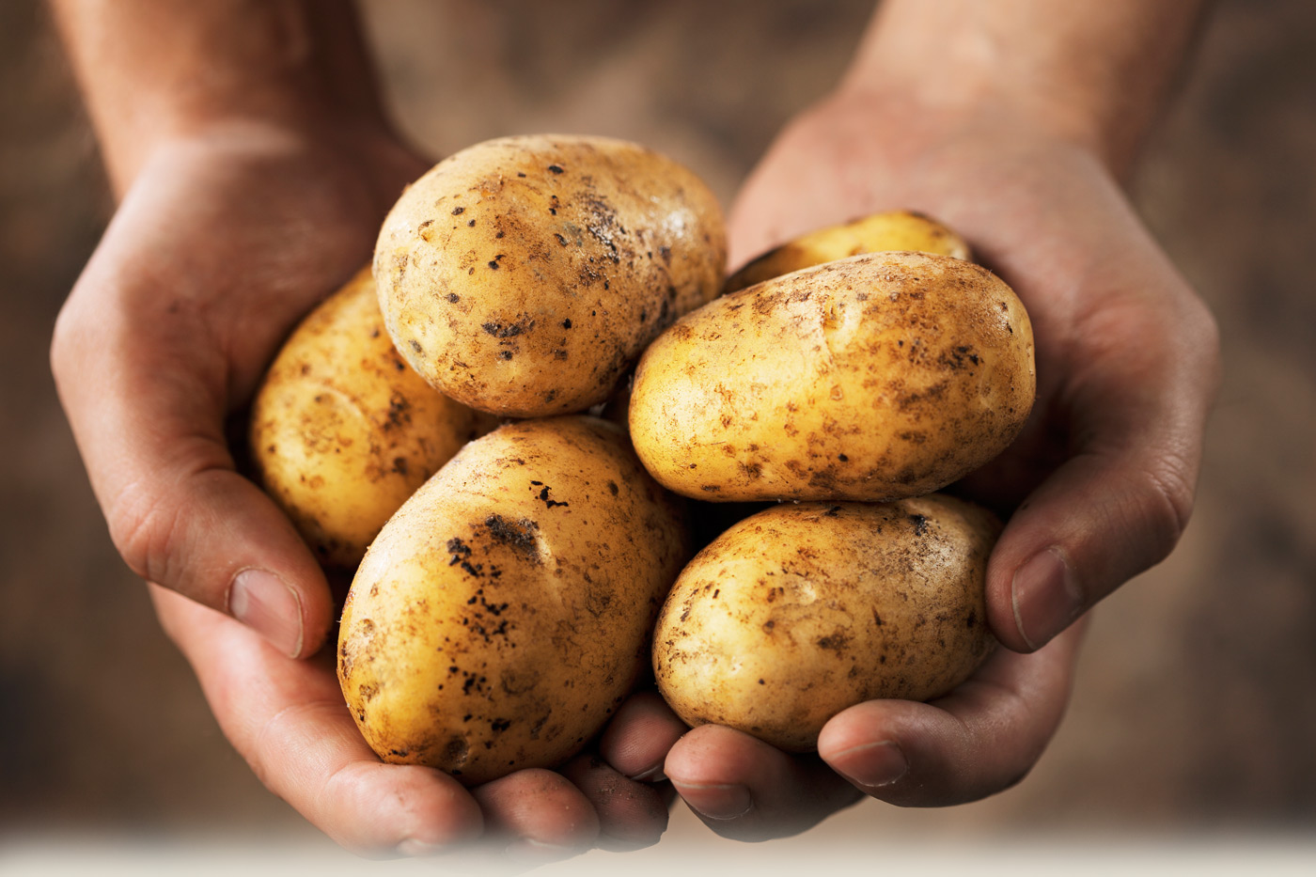
Directions: Estimate first and then solve each problem. Explain if your answer is reasonable.

- On Monday, a farm sold 25,196 pounds of potatoes. On Tuesday, they sold more potatoes. In all, they sold 65,409 pounds of potatoes.
  - ESTIMATE. About how many pounds of potatoes did the farm sell on Tuesday?

  - SOLVE. Find the precise number of pounds of potatoes sold on Tuesday.

  - CHECK REASONABLENESS. Is your precise answer reasonable?

- There are two pools. The big pool holds 241,758 gallons of water. The baby pool holds 113,916 gallons of water.
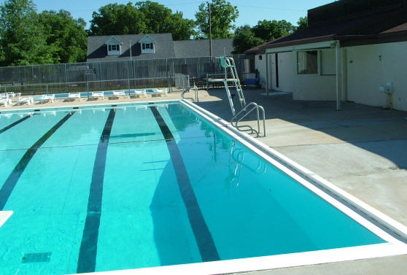
- ESTIMATE. About how many more gallons of water does the big pool hold?

- SOLVE. Find the precise difference between the two pools.

- CHECK REASONABLENESS. Is your precise answer reasonable?

- Martin’s car had 86,456 miles on it. Of that distance, Martin’s partner drove 24,901 miles. Martin drove the rest.
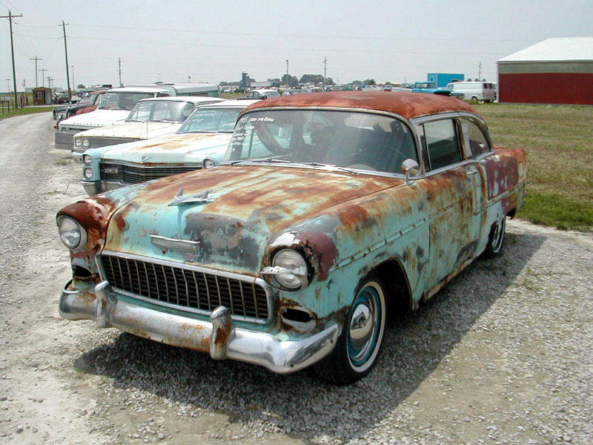
- ESTIMATE. About how many miles did Martin drive?

- SOLVE. Exactly how many miles did Martin drive?

- CHECK REASONABLENESS. Assess the reasonableness of your answer in (b). Use your estimate from (a) to explain.

